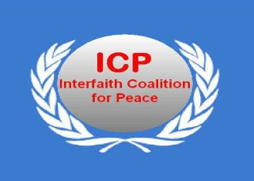

ICP’s National Strategic Planning workshop on
Strengthening Human Resources in Peace Building

April 10-12, 2012
Venue: Dona Alcina Resort, Goa
Facilitator: Arne Saeverass

Day -1 Monday 9th April 2012
Arrival of the Participants
07.30pm - Welcome Dinner

Day -2 Tuesday 10th April 2012
09:30am – 10.30am - Inaugural Session
- Interfaith Prayers
- Welcome Speech and the objective of the Workshop
- Chairperson’s Remarks
- Greetings
10:30am – 11:00am - Tea
11:00am – 12:30pm - Findings of the study Report Presentation - 1
12:30pm – 01:00pm - Group work
01-00pm – 02:30pm - Lunch
02:30pm – 03:30pm - Findings of the study Report Presentation – 2
03:30pm – 04:00pm - Group work
04:00pm – 05:00pm - Group Presentations
07:30pm - 08:30pm - Dinner
08:30pm – 09:30pm - Goa Cultural Programme

Day – 3 Wednesday 11th April 2012
09:00am – 09:30am - Interfaith Prayers
09:30am – 10:00am - Guidelines to Strategic Planning

10:00am –10:30am - Tea

10:30am – 11:30pm - Strategic Planning -1 (ICP’s Regional Network / Women Interfaith Forum)

11:30am – 11:40am - Break

11:40am – 01:00pm - Strategic Planning -2 (ICP’s Regional Network / Women Interfaith Forum)

01:00pm – 02:30pm - Lunch

02:30pm – 04:00pm - Presentations of the Strategic Planning Plenary

04:00pm – 04:30pm - Tea

04:30pm -10:00pm - Sightseeing / Boat Trip / Dinner

Day – 4 Thursday 12th April 2012
09:00am – 09:30am - Interfaith Prayers
09:30am – 10:30am - Presentations of the Strategic Planning Plenary
10:30am – 11:00am - Tea
11:00am – 12:30pm - Regional Meetings / Women Forum Meetings
12:30am – 01:30pm - valedictory Session
01:30pm - Lunch and Departure

